Cl-3001 - Coputer networks lab

LABORATORY MANUAL ⦁Spring 2023 ⦁Student ID – K-21-0026: Muhammad Nadeem

|  |
| --- |
| **LAB 06** |
| **IMPLEMENTATION & UNDERSTANDING OF**  **HTTP/HTTPS AND**  **NETWORK TRAFFIC ANALYSIS OF HTTP/S**  **PROTOCOL HEADERS, COOKIES USING**  **WIRESHARK** |



|  |  |  |  |  |
| --- | --- | --- | --- | --- |
|  | | | | |
|  | | | | |
|  | | | | |
| **S.M.Hassan Ali** | | **K20-1052** | |  |
| ________________________________________ | | __________ | |  |
| STUDENT NAME | | ROLL NO | |  |
|  | | | | |
| ______________________________________ | | | | |
| SIGNATURE & DATE | | | | |
| **MARKS AWARDED: ______________** | | | | |
| ___________________________________________________________________ | | | | |
| **NATIONAL UNIVERSITY OF COMPUTER AND EMERGING SCIENCES (NUCES), KARACHI** | | | | |
| Version: 1.0  Date: 17th **February 2023** | | | | |
| Instructor Name:  Prepared by: | **Muhammad Nadeem Ghouri**  **S.M.HASSAN ALI** |  |  | |

**Lab Session 06**

**Q1.**

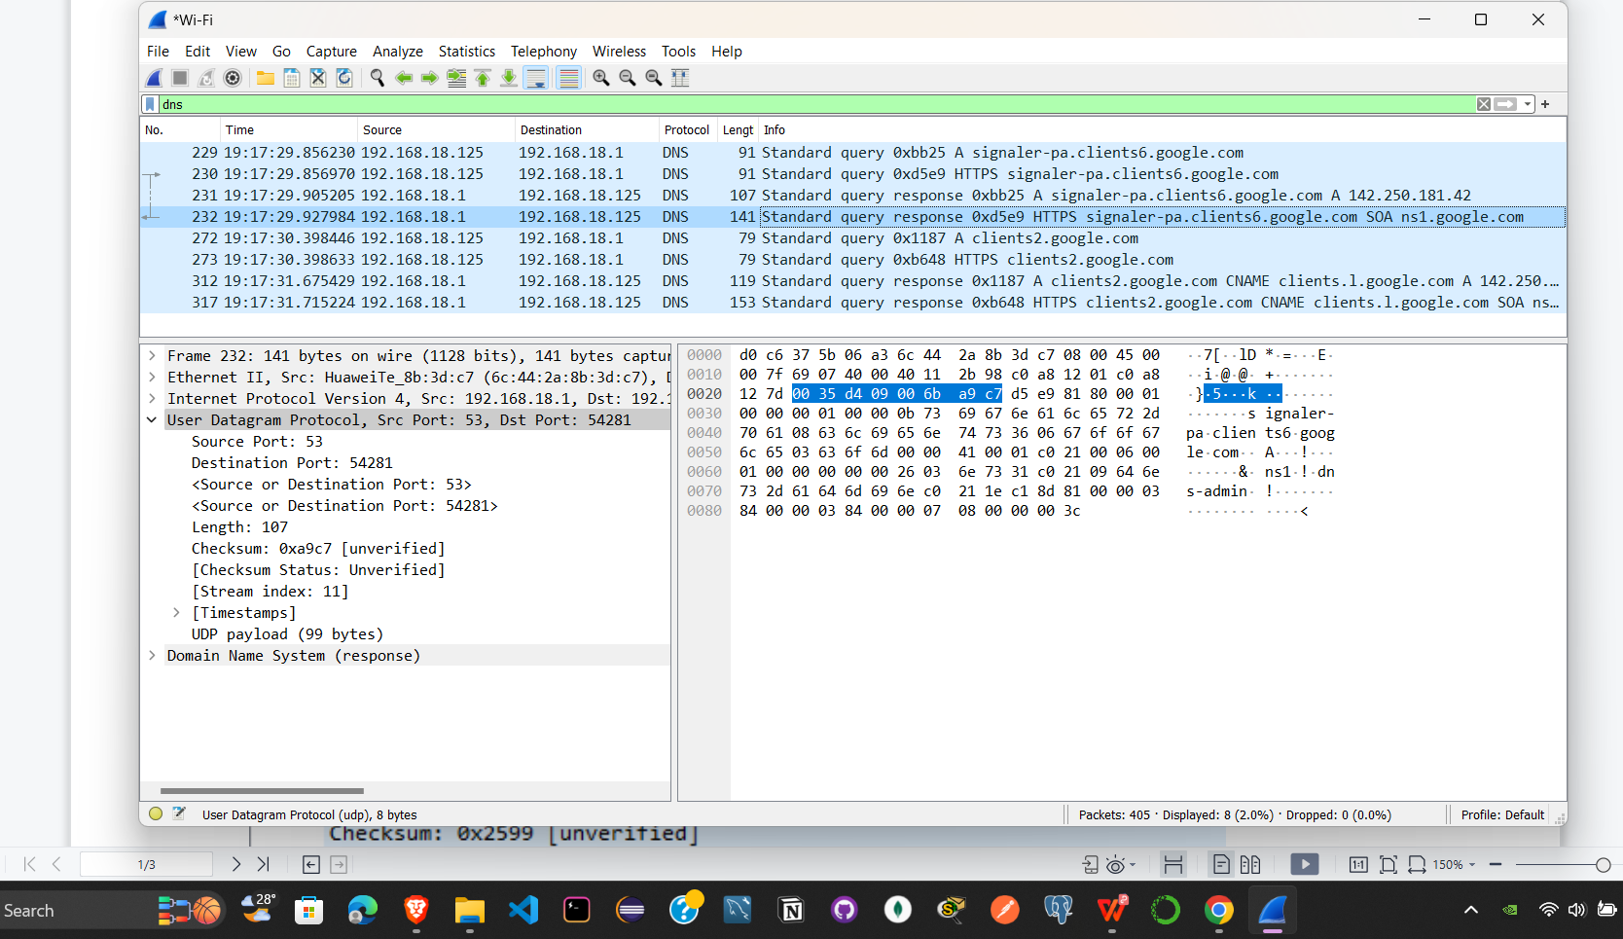

**Q2.**

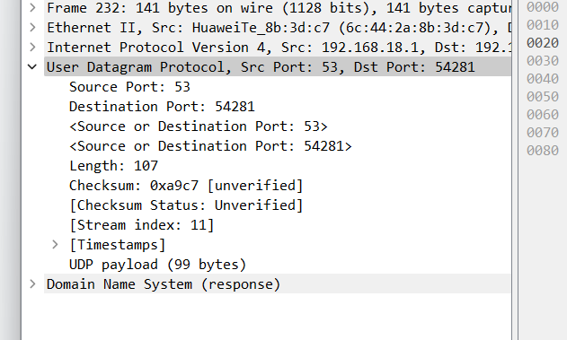

**Q3.**

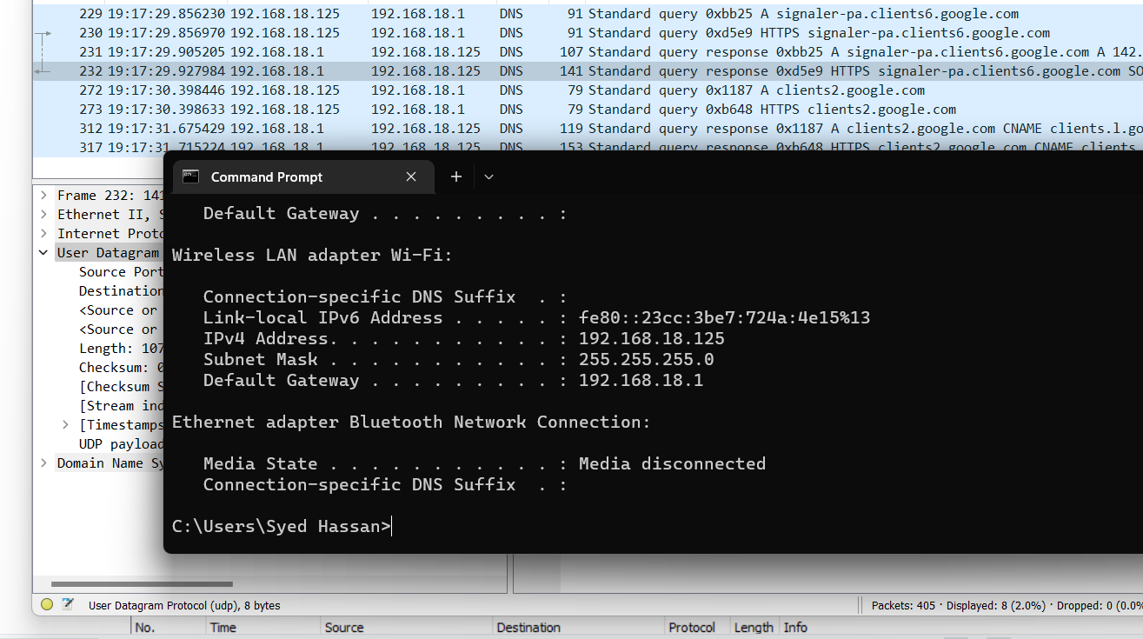

**Q4.**

The query message was a type “A” query and the message contains 2 answers.

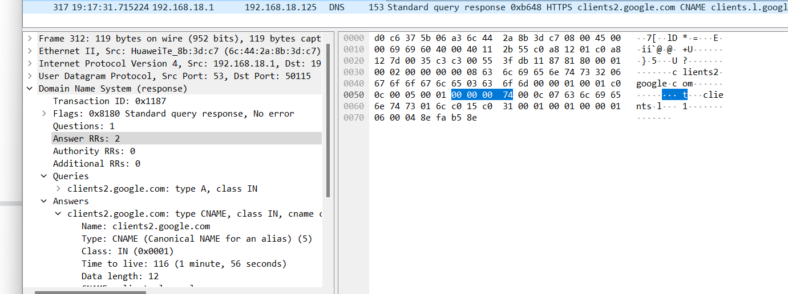

**Q5**.

The response message contained 2 answers to the query which was the site's cname.

Although it also provided 0 authoritative nameservers, and 0 other responses containing

additional information.

